Breakout Barrier Article
There is nothing that takes the enjoyment out of the use of some ones own backyard quite like sewage breakout from a septic drain field. When the soils become saturated with raw sewage to the point of breakout the area cannot be used for any typical backyard activities and the noxious odors associated with this can travel to neighboring properties and in many case right into someone’s home. This situation can lead to more serious public health problems such as the potential exposure of humans to disease carrying pathogens. Furthermore, if the untreated sewage travels over-land to local water resource areas it can contaminate it with nutrients accelerating the natural aging process of the resource area.
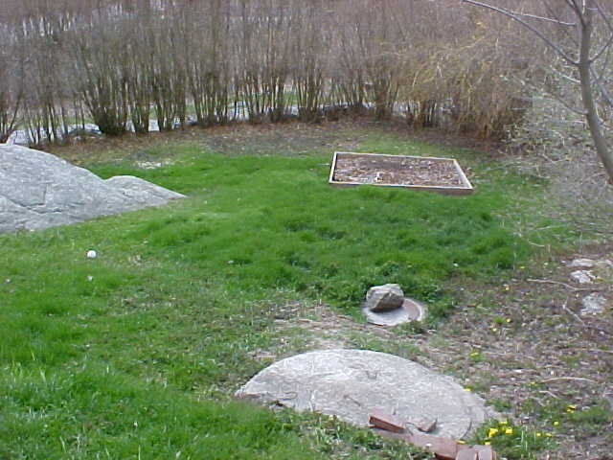
Figure 1 – A recent photograph of a failed septic system with breakout evident from the lush patch of grass shown in the center of the picture. This system not only poses a public health threat to the occupying family and their neighbors it will also effect the health of a nearby wetland that can be seen through the row of trees at the top of the picture. Odors from the breakout of sewage are noticeable when standing near the system as well as in the owners and neighboring dwellings.
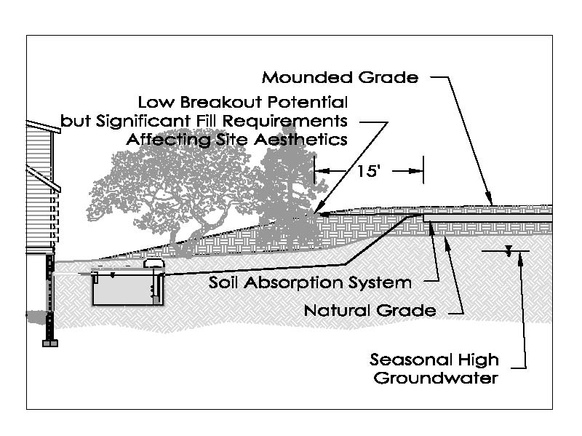

Some state environmental regulations require breakout grading around septic tank leach-fields or soil absorptions systems (SAS). The regulations may require that the breakout grade, typically considered the elevation of the top of the SAS, be held for ten to fifteen feet from the edge of the SAS as shown in Figure 2. While this is a viable method of protecting from side slope breakout it can make designing and installing these systems on small lots difficult.

Figure 2 – Some local authorities may require specific breakout grading requirements. For example, in Massachusetts, designers are required to hold breakout grade for 15-feet from the edge of the SAS and a minimum slope of 3:1 after that. While this lowers the breakout potential significantly it also significantly increases the disturbance area around the SAS and may result in loss of trees, poor site aesthetics and on small lots such grading may not be possible.

In some states and localities this is not even regulated and makes it easy for designers and installers to site and construct a SAS but promotes premature system failure since sewage breakout is a common SAS failure criterion (See Figure 3). Along with the health and environmental problems discussed above, this can also cost property owners significant amounts of money that will be required to have a replacement system designed, permitted and constructed. It can also open the door to engineer or contractor liability as some systems will approach failure much sooner than the expected life cycle of the system.

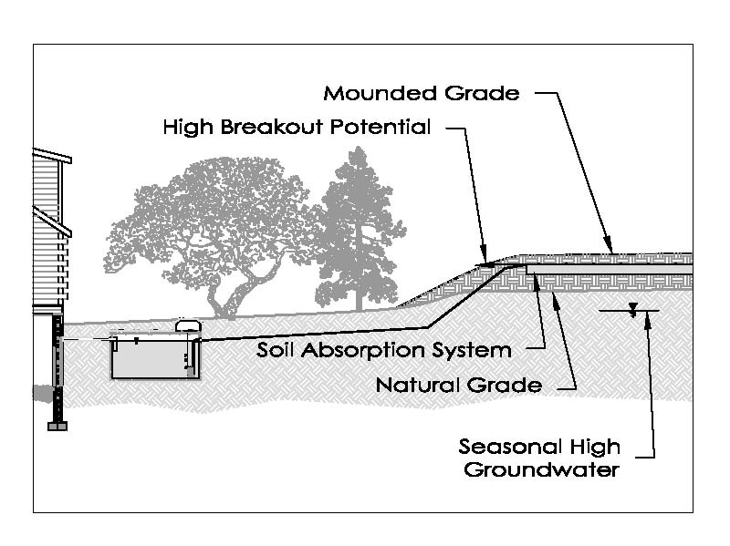
Figure 3 – This figure shows a mounded SAS with only 5-feet of breakout grading; that is, the grade of the top of the SAS is held for only five feet from the edge of the system. This type of system is commonly installed in areas where local regulators have not included breakout grading requirements in their regulations or bylaws. While this type of mounded SAS is easy for engineers to layout and contractors to install it also has high potential of breakout on the side slope.

One solution to these sewage breakout problems is providing an impermeable liner between the SAS and its associated side slopes. The liner will act as an impermeable barrier that will stop the horizontal flow of untreated sewage and force it downward through the underlying soil column. Liners such as this have been in use in regulated states for as long as breakout grading has been required. Some regulators will allow a reduction in breakout grading if an impermeable liner is installed between the SAS and the side slope. These liner installations may also prompt regulators to reduce some setback distances for other regulated receptors or structures such as basement walls.

Traditionally engineers would specify, and installers would install, rubber roofing membrane vertically to meet breakout grade. These barriers tend to breakdown when exposed to the aggressive nature of the naturally occurring soils. Furthermore, installers find these liners difficult to install as they are only available in 10-foot widths and the typical vertical installation depth is only 5-feet. As well they can be very flimsy and difficult to hold vertically at breakout grade while backfilling. This can cause installers to incorrectly place the liner and in some cases the top of the liner may be installed below breakout grade.
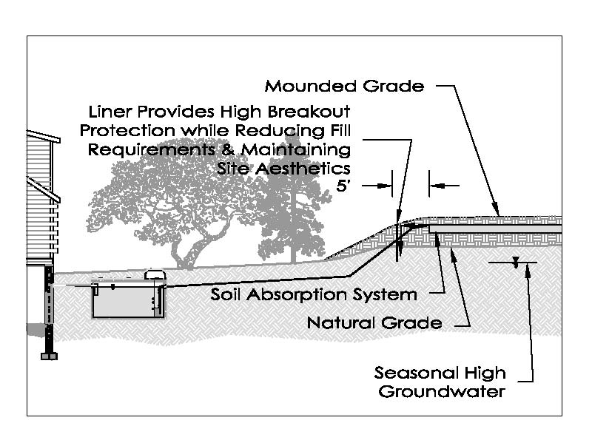

Figure 4 – This figure shows the same mounded system as Figure 3, but has an impermeable 40 mil polyethylene barrier installed vertically 5-feet below grade and 5-feet from the SAS. The barrier prevents the horizontal movement of sewage from the SAS directing it downward at the liner interface. This type of installation will provide superior breakout protection while offering the designer and installer some flexibility when considering site limitations and aesthetics.

An emerging product that overcomes many of the drawbacks of rubber roofing membranes is the Miller Environmental, Inc. Breakout Barrier. This barrier, made of 40 mil polyethylene is chemically and biologically inert and the rigid material is easy to hold in place vertically at the specified breakout elevation during backfilling. The barrier is available in 5-foot and 10-foot rolls of 100-feet which eliminates cutting in the field and material waste. Liner ends can be easily attached to each other in the field using an adhesive tape that makes a water-tight lasting bond for systems that require liners longer than 100-feet.

